

**WINTER INTERNSHIP PROJECT REPORT ON**

**“ONLINE POLLING SYSTEM”**

**USING ADVANCED JAVA**

**(27TH DECEMBER TO 28TH FEBRUARY 2019 AT**

**INDIAN OIL CORPORATION LIMITED, EASTERN REGION**

SUBMITTED BY :

SOUJANNYA ROY

B.TECH. IN COMPUTER SCIENCE AND ENGINEERING

FIFTH SEMISTER

**Acknowledgement**

I would like to express my special gratitude and thanks to my mentor, Shri Subhankar Chakraborty, Sr. Manager(System), Eastern Region for his valuable guidance and constant supervision which helped me in completion of this project. I am thankful to the trainees from NIIT, Kolkata. I would like to extend my sincere thanks to all of them.

My thanks and appreciations also go to the staff of Indian Oil Corporation Ltd., Eastern Region for their help as and when required during my project.

Soujannya Roy

B.Tech.(CSE), 5th Sem

IEM, Salt Lake

**INDEX**

* Abstract
* Introduction to online Polling System
* Background of study
* Significance of study
* Project Justification
* Security issues of online polling
* Software required
* Data Flow Diagram
* Data Flow Diagram with datas
* Database table
* Conclusions

**Abstract**

The word ‘Polling’ means to choose from a list to elect or to determine. The main goal of polling is to come up with leaders of the people’s choice.

The Project is developed for the threat free and user oriented Online Polling System. The Online Voting system is made for the people of the country residing around the world and wants to vote for their representative. The election can be conducted in two ways the paper ballot election and the automated ballot elections.

The automated ballot elections are called the electronic voting. The online polling system is highly developed and the online polling system can be replaced by accurately and directly voting online and immediate results. The online voting system is done by the internet so it can be called the Internet Voting.

**Introduction to Online Polling System**

‘Online Polling System’ is an online voting technique. In this system, people of India who have citizenship and whose age is above 18 years of age can give their vote online without going to any physical polling station.

There is a database which is maintained in which all the names of voters with complete information are stored.

In Online Voting System, a voter can use their voting right online without any difficulty. Voter has to be registered first. Registration is mainly done by the system administrator for security reasons. The system Administrator registers the voters on a special site of the system visited by him only by simply filling a registration form to register voter. Citizens seeking registration are expected to contact the system administrator to submit their details. After the validity of them being citizens of India has been confirmed by the system administrator by comparing their details submitted with those in existing database such as those as the Registrar of persons, the citizen is then registered as a voter.

After registration, the voter is assigned a secret Voter ID with which the voter can use to log into the system and enjoy services provided by the system.

**Background of study**

The Online Voting System (OVS) also known as e-voting is a term encompassing several different types of voting embracing both electronic means of counting votes. Electronic voting technology can include punched cards, optical scan voting systems and specialized voting kiosks.

Online voting is an electronic way of choosing leaders via a web driven application. The advantage of online voting over the common ‘queue method is that the voters have the choice of voting at their own free time and there is reduced congestion. It also minimizes on errors of vote counting. The individual votes are submitted in a database which can be queried to find out who of the aspirants for a given post has the highest number of votes.

With the ‘Online Polling System’, voter can use his/her voting right online without any difficulty.

**Significance of study**

* The main purposes of OVS include :
* Provision of improved voting services to the voter through fast, timely and convenient voting.
* Check to ensure that the members who are registered are the only ones to vote.
* Online voting system will require being very precise or cost cutting to produce an effective election management system.
* The system is a lot easier to independently moderate the election and subsequently reinforce its transparency and fairness.

**Project justification**

The online polling system in India shall reduce the time spend making long queue at the polling stations during voting. It shall also enable the voter to vote from anywhere since this is an online application available on the internet. Cases of vote miscounts shall also be solved since at the backend of this system resides a well-developed database using MYSQL that can provide the correct data once it is correctly queried.

**Security issues of online polling**

The offline experience revealed that they are often confronted by security issues while the online voting system is running. The origin of the security issues was due to not only outsider but also insider even just because the inheritance of some objects in the source code is unsuitable. These errors caused the voting system to crash.

The proposed solutions were correspondingly outlines to holdback these attacks. For example, to avoid hacker making incursion into the voting system via network, we can design our system to transmit data without network. Another example is to limit voter to input particular data, so that we can prevent the command injection from running.

**Software required**

1. **MYSQL DBMS** – It allows combination, extraction, manipulation and organization of data in the voters database. It is platform independent and therefore can be implemented and used across several such as windows, Linux server and is compatible with various hardware mainframes. It is fast in performance, stable and provides business value at a low cost.
2. **NetBeans IDE 7.1.2** – The NetBeans IDE is an award-winning integrated development environment available for Windows, Mac, Linux and Solaris. The NetBeans portal consists of an open-source IDE and an application platform that enable developers to rapidly create web, enterprise, desktop and mobile applications using the Java platform, as well as PHP, JavaScript and Ajax, Groovy and Grails, and C/C++.

The NetBeans project is supported by a vibrant developer community and offers extensive documentation and training resources as well as a diverse selection of third party plugins.

1. **JAVA coding**
2. **Testing** – is done via WAMPSERVER.
3. **Web browsers** – Mozilla Firefox, Google chrome, Opera and internet Explorer.
4. **Reporting Tool** i.e. through Data Report

**Database Table Format**

**Voter details**

|  |  |  |  |
| --- | --- | --- | --- |
| **DESCRIPTION** | **DETATYPE** | **LENGTH** | **NULL / NOT NULL** |
| NAME | VARCHAR | 30 | **NOT NULL** |
| DOB | DATE | 8 | **NOT NULL** |
| GENDER | CHAR | 1 | **NOT NULL** |
| PIN NUMBER | NUMBER | 6 | **NOT NULL** |
| ADGAR NO. | NUMBER | 12 | **NOT NULL** |
| VOTER ID | VERCHAR | 30 | **NOT NULL** |
| PASSWORD | VERCHAR | 20 | **NOT NULL** |

**Constituency Master**

|  |  |  |  |
| --- | --- | --- | --- |
| **DESCRIPTION** | **DETATYPE** | **LENGTH** | **NULL / NOT NULL** |
| NAME | VARCHAR | 30 | **NOT NULL** |
| ID | NUMBER | 10 | **NOT NULL** |

**Assembly Master**

|  |  |  |  |
| --- | --- | --- | --- |
| **DESCRIPTION** | **DETATYPE** | **LENGTH** | **NULL / NOT NULL** |
| NAME | VARCHAR | 30 | **NOT NULL** |
| ID | NUMBER | 10 | **NOT NULL** |

**PIN-Assembly-Constituency Map**

|  |  |  |  |
| --- | --- | --- | --- |
| **DESCRIPTION** | **DETATYPE** | **LENGTH** | **NULL / NOT NULL** |
| PIN NO. | NUMBER | 6 | **NOT NULL** |
| ASSEMBLY ID | NUMBER | 10 | **NOT NULL** |
| CONSTITUENCY ID | NUMBER | 10 | **NOT NULL** |

**Candidate details**

|  |  |  |  |
| --- | --- | --- | --- |
| **DESCRIPTION** | **DETATYPE** | **LENGTH** | **NULL / NOT NULL** |
| CANDIDATE ID | VARCHAR | 10 | **NOT NULL** |
| PARTY ID | VARCHAR | 10 | **NOT NULL** |
| ASSEMBLY ID | VARCHAR | 10 | **NOT NULL** |
| CONSTITUENCY ID | VARCHAR | 10 | **NOT NULL** |
| CANDIDATE NAME | VARCHAR | 20 | **NOT NULL** |

**Party details**

|  |  |  |  |
| --- | --- | --- | --- |
| **DESCRIPTION** | **DETATYPE** | **LENGTH** | **NULL / NOT NULL** |
| PARTY ID | VARCHAR | 10 | **NOT NULL** |
| PARTY NAME | VARCHAR | 20 | **NOT NULL** |
| PARTY SYMBOL | BLOB |  | **NULLABLE** |

**Casting**

|  |  |  |  |
| --- | --- | --- | --- |
| **DESCRIPTION** | **DETATYPE** | **LENGTH** | **NULL / NOT NULL** |
| PARTY ID | VARCHAR | 10 | **NOT NULL** |
| VOTE MAX | NUMBER |  | **NULLABLE** |

DATA FLOW DIAGRAM

**Sign in Flowchart** :

**Capture Voter Details**

**No**

**Age > = 18**

**&&**

**Aadhar Card does not exist in data base**

**Yes**

**Generate id**

**Register Voter**

**Store information and password**

**Login Flowchart :**

**Input id and password**

**No**

**Id in database**

**&& Password**

**wrt id is correct**

**Yes**

**Go to casting page**

**Casting flowchart** :

**No**

**Check if already voted**

No

**Yes**

**Cast of vote in favour of one party**

**Increase in favour of one** party

**Display result flowchart :**

**Fetch result**

**Show result**

1. **Process of flowchart :**

**Sign in**

**Log in**

**Casting**

**Display**

**DATABASE TABLE WITH DATAS**

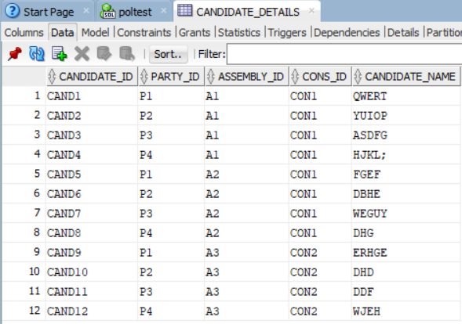

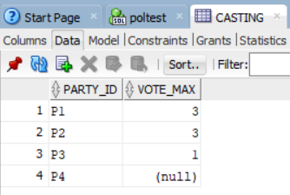

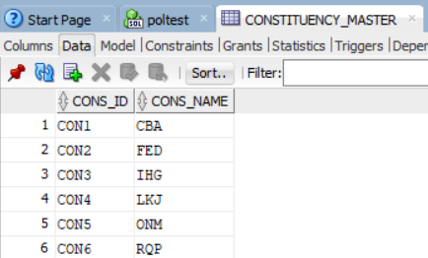

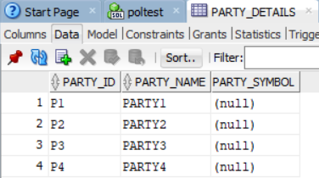

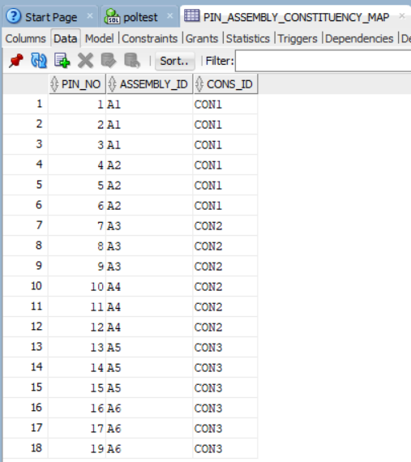

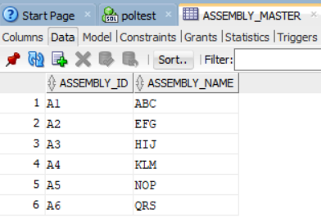

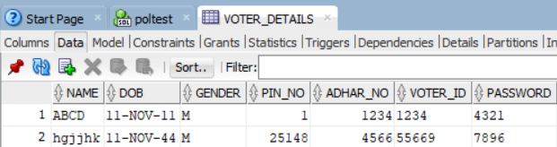

**SOURCE CODE**

**Source Packages:**

**GetDbConn.java**

import java.io.*;

import java.sql.*;

import java.text.SimpleDateFormat;

import java.util.*;

import javax.xml.parsers.DocumentBuilder;

import javax.xml.parsers.DocumentBuilderFactory;

import oracle.jdbc.pool.OraclePooledConnection;

import org.w3c.dom.Document;

import org.w3c.dom.Element;

import org.w3c.dom.Node;

import org.w3c.dom.NodeList;

public class GetDbConn {

SimpleDateFormat sdf = new SimpleDateFormat("yyyy-MM-dd HH:mm:ss");

OraclePooledConnection pc = null;

Connection con = null;

public GetDbConn(){ con=null;}

public Connection GetdbConnection(String is_filename, String is_section) {

String ls_driver = "", ls_jdbc = "", ls_ip = "", ls_host = "";

String ls_login = "", ls_pass = "", ls_db = "";

NodeList nList = null;

try {

File fXmlFile = new File(is_filename);

DocumentBuilderFactory dbFactory = DocumentBuilderFactory.newInstance();

DocumentBuilder dBuilder = dbFactory.newDocumentBuilder();

Document doc = dBuilder.parse(fXmlFile);

doc.getDocumentElement().normalize();

// System.out.println("Root element :" + doc.getDocumentElement().getNodeName());

// System.out.println(is_filename);

nList = doc.getElementsByTagName(is_section);

// System.out.println("-----------------------");

for (int temp = 0; temp < nList.getLength(); temp++) {

Node nNode = nList.item(temp);

if (nNode.getNodeType() == Node.ELEMENT_NODE) {

Element eElement = (Element) nNode;

ls_db = getTagValue("DataBase", eElement);

ls_driver = getTagValue("Driver", eElement);

ls_jdbc = getTagValue("JDBCurl", eElement);

ls_ip = getTagValue("IP", eElement);

ls_host = getTagValue("HOST", eElement);

ls_login = getTagValue("Login", eElement);

ls_pass = getTagValue("Pass", eElement);

}

}

} catch (Exception e) {

e.printStackTrace();

}

try {

Class c = Class.forName(ls_driver);

Driver driver = (Driver) c.newInstance();

DriverManager.registerDriver(driver);

//String ls_url = ls_login + "@//" + ls_ip + ":" + ls_host + "/xe";

//String ls_url = ls_jdbc + ":@" + ls_ip + ":" + ls_host;

String ls_url = "jdbc:oracle:thin:@localhost:1521:xe";

if (ls_db.toUpperCase().equals("ORACLE")) {

// OraclePooledConnection pc=new OraclePooledConnection("jdbc:oracle:thin:@10.10.0.4:1521:glob","eipldba","eiplubq");

if (pc == null) {

System.out.println("pooling");

//pc = new OraclePooledConnection(ls_url, ls_login, ls_pass);

pc = new OraclePooledConnection(ls_url, "poltest", "pol123");

}

con = pc.getConnection();

} else if (ls_db.toUpperCase().equals("SYBASE")) {

con = DriverManager.getConnection(ls_jdbc + ":" + ls_ip + "?ServiceName=" + ls_host, ls_login, ls_pass);

}

Calendar calx = Calendar.getInstance();

System.out.println((new StringBuilder()).append("---------------------------------------------------Start Connection:: ").append(is_section).append("::").append(sdf.format(calx.getTime())).toString());

} catch (Exception conex) {

conex.printStackTrace();

}

return con;

}

private static String getTagValue(String sTag, Element eElement) {

NodeList nlList = eElement.getElementsByTagName(sTag).item(0).getChildNodes();

Node nValue = (Node) nlList.item(0);

return nValue.getNodeValue();

}

public void closeConnection(Connection conn, ResultSet rs, Statement stmt, PreparedStatement pstmt) {

try {

if (rs != null) {

rs.close();

rs = null;

}

System.out.println("GetDbConn -- ResultSet Closed.");

} catch (Exception e) {

e.printStackTrace();

}

try {

if (stmt != null) {

stmt.close();

stmt = null;

}

System.out.println("GetDbConn --Statement Closed.");

} catch (Exception e) {

e.printStackTrace();

}

try {

if (pstmt != null) {

pstmt.close();

pstmt = null;

}

System.out.println("GetDbConn --PreparedStatement Closed.");

} catch (Exception e) {

e.printStackTrace();

}

try {

if (conn != null) {

conn.close();

conn = null;

}

System.out.println("GetDbConn -- Connection Closed.");

Calendar caly = Calendar.getInstance();

System.out.println((new StringBuilder()).append("---------------------------------------------------End Connection :: ").append(sdf.format(caly.getTime())).toString());

} catch (Exception e) {

e.printStackTrace();

}

}

public void closeConnection(Connection conn) {

try {

if (conn != null) {

conn.close();

conn = null;

}

System.out.println("GetDbConn -- Connection Closed.");

Calendar caly = Calendar.getInstance();

System.out.println((new StringBuilder()).append("---------------------------------------------------End Connection :: ").append(sdf.format(caly.getTime())).toString());

} catch (Exception e) {

e.printStackTrace();

}

}

}

/*public static void main(String[] args)

{

linkedList list = new linkedList();

/*public class PolConnect {

public Connection GetConnection()

{

try{

Class c=Class.forName(ls_driver);

//step1 load the driver class

Class.forName("oracle.jdbc.driver.OracleDriver");

//step2 create the connection object

Connection con=DriverManager.getConnection(

"jdbc:oracle:thin:@localhost:1521:xe","system","oracle");

//step3 create the statement object

Statement stmt=con.createStatement();

//step4 execute query

ResultSet rs=stmt.executeQuery("select * from ASSEMBLY_MASTER ");

while(rs.next())

System.out.println(rs.getInt(1)+" "+rs.getString(2)+" "+rs.getString(3));

//step5 close the connection object

con.close();

}catch(Exception e){

System.out.println(e);

}

}

}

}*/

Sign_Up.java

**import java.io.*;**

**import java.sql.*;**

**import java.text.SimpleDateFormat;**

**import java.util.*;**

**import javax.xml.parsers.DocumentBuilder;**

**import javax.xml.parsers.DocumentBuilderFactory;**

**import oracle.jdbc.pool.OraclePooledConnection;**

**import org.w3c.dom.Document;**

**import org.w3c.dom.Element;**

**import org.w3c.dom.Node;**

**import org.w3c.dom.NodeList;**

**public class GetDbConn {**

**SimpleDateFormat sdf = new SimpleDateFormat("yyyy-MM-dd HH:mm:ss");**

**OraclePooledConnection pc = null;**

**Connection con = null;**

**public GetDbConn(){ con=null;}**

**public Connection GetdbConnection(String is_filename, String is_section) {**

**String ls_driver = "", ls_jdbc = "", ls_ip = "", ls_host = "";**

**String ls_login = "", ls_pass = "", ls_db = "";**

**NodeList nList = null;**

**try {**

**File fXmlFile = new File(is_filename);**

**DocumentBuilderFactory dbFactory = DocumentBuilderFactory.newInstance();**

**DocumentBuilder dBuilder = dbFactory.newDocumentBuilder();**

**Document doc = dBuilder.parse(fXmlFile);**

**doc.getDocumentElement().normalize();**

**// System.out.println("Root element :" + doc.getDocumentElement().getNodeName());**

**// System.out.println(is_filename);**

**nList = doc.getElementsByTagName(is_section);**

**// System.out.println("-----------------------");**

**for (int temp = 0; temp < nList.getLength(); temp++) {**

**Node nNode = nList.item(temp);**

**if (nNode.getNodeType() == Node.ELEMENT_NODE) {**

**Element eElement = (Element) nNode;**

**ls_db = getTagValue("DataBase", eElement);**

**ls_driver = getTagValue("Driver", eElement);**

**ls_jdbc = getTagValue("JDBCurl", eElement);**

**ls_ip = getTagValue("IP", eElement);**

**ls_host = getTagValue("HOST", eElement);**

**ls_login = getTagValue("Login", eElement);**

**ls_pass = getTagValue("Pass", eElement);**

**}**

**}**

**} catch (Exception e) {**

**e.printStackTrace();**

**}**

**try {**

**Class c = Class.forName(ls_driver);**

**Driver driver = (Driver) c.newInstance();**

**DriverManager.registerDriver(driver);**

**//String ls_url = ls_login + "@//" + ls_ip + ":" + ls_host + "/xe";**

**//String ls_url = ls_jdbc + ":@" + ls_ip + ":" + ls_host;**

**String ls_url = "jdbc:oracle:thin:@localhost:1521:xe";**

**if (ls_db.toUpperCase().equals("ORACLE")) {**

**// OraclePooledConnection pc=new OraclePooledConnection("jdbc:oracle:thin:@10.10.0.4:1521:glob","eipldba","eiplubq");**

**if (pc == null) {**

**System.out.println("pooling");**

**//pc = new OraclePooledConnection(ls_url, ls_login, ls_pass);**

**pc = new OraclePooledConnection(ls_url, "poltest", "pol123");**

**}**

**con = pc.getConnection();**

**} else if (ls_db.toUpperCase().equals("SYBASE")) {**

**con = DriverManager.getConnection(ls_jdbc + ":" + ls_ip + "?ServiceName=" + ls_host, ls_login, ls_pass);**

**}**

**Calendar calx = Calendar.getInstance();**

**System.out.println((new StringBuilder()).append("---------------------------------------------------Start Connection:: ").append(is_section).append("::").append(sdf.format(calx.getTime())).toString());**

**} catch (Exception conex) {**

**conex.printStackTrace();**

**}**

**return con;**

**}**

**private static String getTagValue(String sTag, Element eElement) {**

**NodeList nlList = eElement.getElementsByTagName(sTag).item(0).getChildNodes();**

**Node nValue = (Node) nlList.item(0);**

**return nValue.getNodeValue();**

**}**

**public void closeConnection(Connection conn, ResultSet rs, Statement stmt, PreparedStatement pstmt) {**

**try {**

**if (rs != null) {**

**rs.close();**

**rs = null;**

**}**

**System.out.println("GetDbConn -- ResultSet Closed.");**

**} catch (Exception e) {**

**e.printStackTrace();**

**}**

**try {**

**if (stmt != null) {**

**stmt.close();**

**stmt = null;**

**}**

**System.out.println("GetDbConn --Statement Closed.");**

**} catch (Exception e) {**

**e.printStackTrace();**

**}**

**try {**

**if (pstmt != null) {**

**pstmt.close();**

**pstmt = null;**

**}**

**System.out.println("GetDbConn --PreparedStatement Closed.");**

**} catch (Exception e) {**

**e.printStackTrace();**

**}**

**try {**

**if (conn != null) {**

**conn.close();**

**conn = null;**

**}**

**System.out.println("GetDbConn -- Connection Closed.");**

**Calendar caly = Calendar.getInstance();**

**System.out.println((new StringBuilder()).append("---------------------------------------------------End Connection :: ").append(sdf.format(caly.getTime())).toString());**

**} catch (Exception e) {**

**e.printStackTrace();**

**}**

**}**

**public void closeConnection(Connection conn) {**

**try {**

**if (conn != null) {**

**conn.close();**

**conn = null;**

**}**

**System.out.println("GetDbConn -- Connection Closed.");**

**Calendar caly = Calendar.getInstance();**

**System.out.println((new StringBuilder()).append("---------------------------------------------------End Connection :: ").append(sdf.format(caly.getTime())).toString());**

**} catch (Exception e) {**

**e.printStackTrace();**

**}**

**}**

**}**

**/*public static void main(String[] args)**

**{**

**linkedList list = new linkedList();**

**/*public class PolConnect {**

**public Connection GetConnection()**

**{**

**try{**

**Class c=Class.forName(ls_driver);**

**//step1 load the driver class**

**Class.forName("oracle.jdbc.driver.OracleDriver");**

**//step2 create the connection object**

**Connection con=DriverManager.getConnection(**

**"jdbc:oracle:thin:@localhost:1521:xe","system","oracle");**

**//step3 create the statement object**

**Statement stmt=con.createStatement();**

**//step4 execute query**

**ResultSet rs=stmt.executeQuery("select * from ASSEMBLY_MASTER ");**

**while(rs.next())**

**System.out.println(rs.getInt(1)+" "+rs.getString(2)+" "+rs.getString(3));**

**//step5 close the connection object**

**con.close();**

**}catch(Exception e){**

**System.out.println(e);**

**}**

**}**

**}**

**}*/**

**Casting.java**

**/\***

**\* To change this license header, choose License Headers in Project Properties.**

**\* To change this template file, choose Tools | Templates**

**\* and open the template in the editor.**

**\*/**

**import java.io.IOException;**

**import java.io.PrintWriter;**

**import java.sql.Connection;**

**import java.sql.PreparedStatement;**

**import java.sql.ResultSet;**

**import java.sql.SQLException;**

**import java.sql.Statement;**

**import java.util.logging.Level;**

**import java.util.logging.Logger;**

**import javax.servlet.ServletException;**

**import javax.servlet.http.HttpServlet;**

**import javax.servlet.http.HttpServletRequest;**

**import javax.servlet.http.HttpServletResponse;**

**/\*\***

**\***

**\* @author SUJANYA**

**\*/**

**public class casting extends HttpServlet {**

**/\*\***

**\* Processes requests for both HTTP <code>GET</code> and <code>POST</code>**

**\* methods.**

**\***

**\* @param request servlet request**

**\* @param response servlet response**

**\* @throws ServletException if a servlet-specific error occurs**

**\* @throws IOException if an I/O error occurs**

**\*/**

**protected void processRequest(HttpServletRequest request, HttpServletResponse response)**

**throws ServletException, IOException {**

**response.setContentType("text/html;charset=UTF-8");**

**try (PrintWriter out = response.getWriter()) {**

**/* TODO output your page here. You may use following sample code.**

**out.println("<!DOCTYPE html>");**

**out.println("<html>");**

**out.println("<head>");**

**out.println("<title>Servlet casting</title>");**

**out.println("</head>");**

**out.println("<body>");**

**out.println("<h1>Servlet casting at " + request.getContextPath() + "</h1>");**

**out.println("</body>");**

**out.println("</html>");**

**}**

**}*/**

**Connection co=null;**

**GetDbConn gd=new GetDbConn();**

**try {**

**co = gd.GetdbConnection("OnlinePoleConn.xml", "ONPOLL");**

**Statement stmt = null;**

**ResultSet rs = null;**

**String unm = "";**

**PreparedStatement pst = null;**

**/* TODO output your page here. You may use following sample code. */**

**stmt = co.createStatement();**

**String vote_id = request.getParameter("vote_id");**

**// String ls_sql = "SELECT COUNT(*) FROM Table CASTING where PARTY_ID = " + P1 + " and PARTY_2 = " + p2 +" and PARTY_3 = " + p3 + " and PARTY_4 = " + p4;**

**// rs = stmt.executeQuery(ls_sql);**

**/* int p1 = "SELECT COUNT(*) FROM Table CASTING where PARTY_1 = " + p1;**

**int p2 = "SELECT COUNT(*) FROM Table CASTING where PARTY_2 = " + p2;**

**int p3 = "SELECT COUNT(*) FROM Table CASTING where PARTY_3 = " + p3;**

**int p4 = "SELECT COUNT(*) FROM Table CASTING where PARTY_4 = " + p4;*/**

**String ls_sql = "SELECT VOTE_MAX FROM CASTING where PARTY_ID = '" + vote_id +"'";**

**rs = stmt.executeQuery(ls_sql);**

**int max_no=0;**

**while (rs.next()) {**

**max_no = rs.getInt(1);**

**}**

**rs.close();**

**max_no = max_no + 1;**

**ls_sql = "update CASTING set VOTE_MAX = "+max_no+"where PARTY_ID = '"+vote_id+"'";**

**pst = co.prepareStatement(ls_sql);**

**try{**

**pst.executeUpdate();**

**pst.close();**

**// try{**

**// co.commit();**

**// out.println("<script>");**

**//out.println("alert('Successfull');");**

**//out.println("</script>");**

**request.getRequestDispatcher("index.html").forward(request,response);**

**/* TODO output your page here. You may use following sample code. */**

**}catch(Exception ex2){**

**out.println("Error in commit--->"+ex2.getMessage());**

**}**

**}catch(Exception ex1){**

**out.println("Error in Query--->"+ex1.getMessage());**

**}**

**} catch (Exception ex3) {**

**System.out.println("Error in Query--->" + ex3.getMessage());**

**}**

**}**

**// <editor-fold defaultstate="collapsed" desc="HttpServlet methods. Click on the + sign on the left to edit the code.">**

**/\*\***

**\* Handles the HTTP <code>GET</code> method.**

**\***

**\* @param request servlet request**

**\* @param response servlet response**

**\* @throws ServletException if a servlet-specific error occurs**

**\* @throws IOException if an I/O error occurs**

**\*/**

**@Override**

**protected void doGet(HttpServletRequest request, HttpServletResponse response)**

**throws ServletException, IOException {**

**processRequest(request, response);**

**}**

**/\*\***

**\* Handles the HTTP <code>POST</code> method.**

**\***

**\* @param request servlet request**

**\* @param response servlet response**

**\* @throws ServletException if a servlet-specific error occurs**

**\* @throws IOException if an I/O error occurs**

**\*/**

**@Override**

**protected void doPost(HttpServletRequest request, HttpServletResponse response)**

**throws ServletException, IOException {**

**processRequest(request, response);**

**}**

**/\*\***

**\* Returns a short description of the servlet.**

**\***

**\* @return a String containing servlet description**

**\*/**

**@Override**

**public String getServletInfo() {**

**return "Short description";**

**}// </editor-fold>**

**}**

log_in.java

**/\***

**\* To change this license header, choose License Headers in Project Properties.**

**\* To change this template file, choose Tools | Templates**

**\* and open the template in the editor.**

**\*/**

**import java.io.IOException;**

**import java.io.PrintWriter;**

**import java.sql.*;**

**import java.util.logging.Level;**

**import java.util.logging.Logger;**

**import javax.servlet.ServletException;**

**import javax.servlet.http.HttpServlet;**

**import javax.servlet.http.HttpServletRequest;**

**import javax.servlet.http.HttpServletResponse;**

**/\*\***

**\***

**\* @author SUJANYA**

**\*/**

**public class log_in extends HttpServlet {**

**/\*\***

**\* Processes requests for both HTTP <code>GET</code> and <code>POST</code>**

**\* methods.**

**\***

**\* @param request servlet request**

**\* @param response servlet response**

**\* @throws ServletException if a servlet-specific error occurs**

**\* @throws IOException if an I/O error occurs**

**\*/**

**protected void processRequest(HttpServletRequest request, HttpServletResponse response)**

**throws ServletException, IOException {**

**response.setContentType("text/html;charset=UTF-8");**

**Connection co = null;**

**GetDbConn gd = new GetDbConn();**

**try {**

**co = gd.GetdbConnection("OnlinePoleConn.xml", "ONPOLL");**

**Statement stmt = null;**

**ResultSet rs = null;**

**String unm = "";**

**PreparedStatement pst = null;**

**/* TODO output your page here. You may use following sample code. */**

**stmt = co.createStatement();**

**String password = request.getParameter("pass");**

**int adhar = Integer.parseInt(request.getParameter("ano").toString());**

**String ls_sql = "SELECT COUNT(*) FROM VOTER_DETAILS where ADHAR_NO = " + adhar;**

**try {**

**rs = stmt.executeQuery(ls_sql);**

**int ad = 0;**

**while (rs.next()) {**

**ad = rs.getInt(1);**

**}**

**rs.close();**

**try {**

**if (ad > 0) {**

**String ps_sql = "SELECT COUNT(*) FROM VOTER_DETAILS where PASSWORD = '" + password + "' and ADHAR_NO= " + adhar;**

**rs = stmt.executeQuery(ps_sql);**

**int adps = 0;**

**while (rs.next()) {**

**adps = rs.getInt(1);**

**}**

**rs.close();**

**if (adps > 0) {**

**request.getRequestDispatcher("casting_page.html").forward(request,response);**

**// response.sendRedirect("casting_page.html");**

**// return;**

**} else {**

**System.out.println("WRONG PASSWORD");**

**}**

**} else {**

**System.out.println("WRONG ADHAR_NO");**

**}**

**} catch (Exception ex1) {**

**System.out.println("Error in Query--->" + ex1.getMessage());**

**}**

**} catch (Exception ex2) {**

**System.out.println("Error in Query--->" + ex2.getMessage());**

**}**

**} catch (Exception ex3) {**

**System.out.println("Error in Query--->" + ex3.getMessage());**

**}**

**}**

**// <editor-fold defaultstate="collapsed" desc="HttpServlet methods. Click on the + sign on the left to edit the code.">**

**/\*\***

**\* Handles the HTTP <code>GET</code> method.**

**\***

**\* @param request servlet request**

**\* @param response servlet response**

**\* @throws ServletException if a servlet-specific error occurs**

**\* @throws IOException if an I/O error occurs**

**\*/**

**@Override**

**protected void doGet(HttpServletRequest request, HttpServletResponse response)**

**throws ServletException, IOException {**

**try {**

**processRequest(request, response);**

**} catch (Exception ex) {**

**Logger.getLogger(Sign_Up.class.getName()).log(Level.SEVERE, null, ex);**

**}**

**}**

**/\*\***

**\* Handles the HTTP <code>POST</code> method.**

**\***

**\* @param request servlet request**

**\* @param response servlet response**

**\* @throws ServletException if a servlet-specific error occurs**

**\* @throws IOException if an I/O error occurs**

**\*/**

**@Override**

**protected void doPost(HttpServletRequest request, HttpServletResponse response)**

**throws ServletException, IOException {**

**try {**

**processRequest(request, response);**

**} catch (Exception ex) {**

**Logger.getLogger(Sign_Up.class.getName()).log(Level.SEVERE, null, ex);**

**}**

**}**

**/\*\***

**\* Returns a short description of the servlet.**

**\***

**\* @return a String containing servlet description**

**\*/**

**@Override**

**public String getServletInfo() {**

**return "Short description";**

**}// </editor-fold>**

**}**

Result.java

**/\***

**\* To change this license header, choose License Headers in Project Properties.**

**\* To change this template file, choose Tools | Templates**

**\* and open the template in the editor.**

**\*/**

**import java.io.IOException;**

**import java.io.PrintWriter;**

**import java.sql.*;**

**import java.util.logging.Level;**

**import java.util.logging.Logger;**

**import javax.servlet.ServletException;**

**import javax.servlet.http.HttpServlet;**

**import javax.servlet.http.HttpServletRequest;**

**import javax.servlet.http.HttpServletResponse;**

**/\*\***

**\***

**\* @author SUJANYA**

**\*/**

**public class log_in extends HttpServlet {**

**/\*\***

**\* Processes requests for both HTTP <code>GET</code> and <code>POST</code>**

**\* methods.**

**\***

**\* @param request servlet request**

**\* @param response servlet response**

**\* @throws ServletException if a servlet-specific error occurs**

**\* @throws IOException if an I/O error occurs**

**\*/**

**protected void processRequest(HttpServletRequest request, HttpServletResponse response)**

**throws ServletException, IOException {**

**response.setContentType("text/html;charset=UTF-8");**

**Connection co = null;**

**GetDbConn gd = new GetDbConn();**

**try {**

**co = gd.GetdbConnection("OnlinePoleConn.xml", "ONPOLL");**

**Statement stmt = null;**

**ResultSet rs = null;**

**String unm = "";**

**PreparedStatement pst = null;**

**/* TODO output your page here. You may use following sample code. */**

**stmt = co.createStatement();**

**String password = request.getParameter("pass");**

**int adhar = Integer.parseInt(request.getParameter("ano").toString());**

**String ls_sql = "SELECT COUNT(*) FROM VOTER_DETAILS where ADHAR_NO = " + adhar;**

**try {**

**rs = stmt.executeQuery(ls_sql);**

**int ad = 0;**

**while (rs.next()) {**

**ad = rs.getInt(1);**

**}**

**rs.close();**

**try {**

**if (ad > 0) {**

**String ps_sql = "SELECT COUNT(*) FROM VOTER_DETAILS where PASSWORD = '" + password + "' and ADHAR_NO= " + adhar;**

**rs = stmt.executeQuery(ps_sql);**

**int adps = 0;**

**while (rs.next()) {**

**adps = rs.getInt(1);**

**}**

**rs.close();**

**if (adps > 0) {**

**request.getRequestDispatcher("casting_page.html").forward(request,response);**

**// response.sendRedirect("casting_page.html");**

**// return;**

**} else {**

**System.out.println("WRONG PASSWORD");**

**}**

**} else {**

**System.out.println("WRONG ADHAR_NO");**

**}**

**} catch (Exception ex1) {**

**System.out.println("Error in Query--->" + ex1.getMessage());**

**}**

**} catch (Exception ex2) {**

**System.out.println("Error in Query--->" + ex2.getMessage());**

**}**

**} catch (Exception ex3) {**

**System.out.println("Error in Query--->" + ex3.getMessage());**

**}**

**}**

**// <editor-fold defaultstate="collapsed" desc="HttpServlet methods. Click on the + sign on the left to edit the code.">**

**/\*\***

**\* Handles the HTTP <code>GET</code> method.**

**\***

**\* @param request servlet request**

**\* @param response servlet response**

**\* @throws ServletException if a servlet-specific error occurs**

**\* @throws IOException if an I/O error occurs**

**\*/**

**@Override**

**protected void doGet(HttpServletRequest request, HttpServletResponse response)**

**throws ServletException, IOException {**

**try {**

**processRequest(request, response);**

**} catch (Exception ex) {**

**Logger.getLogger(Sign_Up.class.getName()).log(Level.SEVERE, null, ex);**

**}**

**}**

**/\*\***

**\* Handles the HTTP <code>POST</code> method.**

**\***

**\* @param request servlet request**

**\* @param response servlet response**

**\* @throws ServletException if a servlet-specific error occurs**

**\* @throws IOException if an I/O error occurs**

**\*/**

**@Override**

**protected void doPost(HttpServletRequest request, HttpServletResponse response)**

**throws ServletException, IOException {**

**try {**

**processRequest(request, response);**

**} catch (Exception ex) {**

**Logger.getLogger(Sign_Up.class.getName()).log(Level.SEVERE, null, ex);**

**}**

**}**

**/\*\***

**\* Returns a short description of the servlet.**

**\***

**\* @return a String containing servlet description**

**\*/**

**@Override**

**public String getServletInfo() {**

**return "Short description";**

**}// </editor-fold>**

**}**

sign_in.java

/*

* To change this license header, choose License Headers in Project Properties.

* To change this template file, choose Tools | Templates

* and open the template in the editor.

*/

import java.io.IOException;

import java.io.PrintWriter;

import java.sql.Connection;

import java.sql.ResultSet;

import java.sql.SQLException;

import java.sql.Statement;

import java.util.logging.Level;

import java.util.logging.Logger;

import javax.servlet.ServletException;

import javax.servlet.annotation.WebServlet;

import javax.servlet.http.HttpServlet;

import javax.servlet.http.HttpServletRequest;

import javax.servlet.http.HttpServletResponse;

/**

*

* @author USER

*/

@WebServlet(urlPatterns = {"/signin_to_login_servlet"})

public class sign_in extends HttpServlet {

/**

* Processes requests for both HTTP <code>GET</code> and <code>POST</code>

* methods.

*

* @param request servlet request

* @param response servlet response

* @throws ServletException if a servlet-specific error occurs

* @throws IOException if an I/O error occurs

*/

protected void processRequest(HttpServletRequest request, HttpServletResponse response)

throws ServletException, IOException, SQLException {

response.setContentType("text/html;charset=UTF-8");

Connection co = null;

try (PrintWriter out = response.getWriter()) {

GetDbConn gd=new GetDbConn();

try {

co = gd.GetdbConnection("OnlinePoleConn.xml", "ONPOLL");

Statement st=null;

ResultSet rs=null;

String unm="";

/* TODO output your page here. You may use following sample code. */

String name=request.getParameter("name");

String password=request.getParameter("psw");

String dob=request.getParameter("dob");

String gen=request.getParameter("gender");

String vid=request.getParameter("vid");

int adhar=Integer.parseInt(request.getParameter("ano"));

int pin=Integer.parseInt(request.getParameter("pno"));

/* st=co.createStatement();

String query="select * from VOTER_DETAILS where name="+username;

rs=st.executeQuery(query);*/

String query = "insert into voter_details(NAME,DOB,GENDER,PIN_NO,ADHAR_NO,VOTER_ID,PASSWORD)"

+ " values('"+name+"','"+password+"','"+vid+"',"+adhar+","+pin+","+gen+","+dob+")";

/*PreparedStatement pst = connect.prepareStatement(query);

pst.setString(1, username.getText()); // what 1 refers to

pst.setString(2, passwordField.getText()); // 2*/

try{

st.executeUpdate(query);

try{

co.commit();

/* while(rs.next()){

unm=rs.getString(1);

}*/

out.println("<script>");

out.println("alert('Successfull');");

out.println("Location='index.html'");

out.println("</script>");

/* TODO output your page here. You may use following sample code. */

}catch(Exception ex2){

out.println("Error in commit--->"+ex2.getMessage());

}

}catch(Exception ex1){

out.println("Error in Query--->"+ex1.getMessage());

}

}catch(Exception ex){

out.println("Error in getting connection--->"+ex.getMessage());

}

}

}

// <editor-fold defaultstate="collapsed" desc="HttpServlet methods. Click on the + sign on the left to edit the code.">

/**

* Handles the HTTP <code>GET</code> method.

*

* @param request servlet request

* @param response servlet response

* @throws ServletException if a servlet-specific error occurs

* @throws IOException if an I/O error occurs

*/

@Override

protected void doGet(HttpServletRequest request, HttpServletResponse response)

throws ServletException, IOException {

try {

processRequest(request, response);

} catch (SQLException ex) {

Logger.getLogger(sign_in.class.getName()).log(Level.SEVERE, null, ex);

}

}

/**

* Handles the HTTP <code>POST</code> method.

*

* @param request servlet request

* @param response servlet response

* @throws ServletException if a servlet-specific error occurs

* @throws IOException if an I/O error occurs

*/

@Override

protected void doPost(HttpServletRequest request, HttpServletResponse response)

throws ServletException, IOException {

try {

processRequest(request, response);

} catch (SQLException ex) {

Logger.getLogger(sign_in.class.getName()).log(Level.SEVERE, null, ex);

}

}

/**

* Returns a short description of the servlet.

*

* @return a String containing servlet description

*/

@Override

public String getServletInfo() {

return "Short description";

}// </editor-fold>

}

Web Pages:

META-INF

context.xml

<?xml version="1.0" encoding="UTF-8"?>

<Context antiJARLocking="true" path="/online_poll"/>

WEB-INF

web.xml

<?xml version="1.0" encoding="UTF-8"?>

<web-app version="3.1" xmlns="http://xmlns.jcp.org/xml/ns/javaee" xmlns:xsi="http://www.w3.org/2001/XMLSchema-instance" xsi:schemaLocation="http://xmlns.jcp.org/xml/ns/javaee http://xmlns.jcp.org/xml/ns/javaee/web-app_3_1.xsd">

<servlet>

<servlet-name>Sign_Up</servlet-name>

<servlet-class>Sign_Up</servlet-class>

</servlet>

<servlet>

<servlet-name>log_in</servlet-name>

<servlet-class>log_in</servlet-class>

</servlet>

<servlet>

<servlet-name>casting</servlet-name>

<servlet-class>casting</servlet-class>

</servlet>

<servlet>

<servlet-name>result</servlet-name>

<servlet-class>result</servlet-class>

</servlet>

<servlet-mapping>

<servlet-name>Sign_Up</servlet-name>

<url-pattern>/Sign_Up</url-pattern>

</servlet-mapping>

<servlet-mapping>

<servlet-name>log_in</servlet-name>

<url-pattern>/log_in</url-pattern>

</servlet-mapping>

<servlet-mapping>

<servlet-name>casting</servlet-name>

<url-pattern>/casting</url-pattern>

</servlet-mapping>

<servlet-mapping>

<servlet-name>result</servlet-name>

<url-pattern>/result</url-pattern>

</servlet-mapping>

<session-config>

<session-timeout>

30

</session-timeout>

</session-config>

<welcome-file-list>

<welcome-file>index.html</welcome-file>

</welcome-file-list>

</web-app>

Unsuccessful.jsp

<%--

Document : log_in

Created on : Feb 19, 2019, 12:35:12 PM

Author : SUJANYA

--%>

<%@page contentType="text/html" pageEncoding="UTF-8"%>

<!DOCTYPE html>

<html>

<head>

<meta http-equiv="Content-Type" content="text/html; charset=UTF-8">

<title>JSP Page</title>

</head>

<body>

<h1>Wrong password</h1>

</body>

</html>

casting_page.html

Top of Form

## PARTY 1

VOTE FOR PARTY 1

## PARTY 2

VOTE FOR PARTY 2

## PARTY 3

VOTE FOR PARTY 3

## PARTY 4

VOTE FOR PARTY 4



Bottom of Form

display_result.jsp

**<%--**

**Document : display_result**

**Created on : 25 Jan, 2019, 4:57:26 PM**

**Author : USER**

**--%>**

**<%@page contentType="text/html" pageEncoding="UTF-8"%>**

**<!DOCTYPE html>**

**<html>**

**<head>**

**<meta http-equiv="Content-Type" content="text/html; charset=UTF-8">**

**<title>JSP Page</title>**

**<style>**

**STYLE type="text/css">**

**h1 { text-align: center}**

**h1 {**

**display: block;**

**font-size: 2em;**

**margin-top: 0.67em;**

**margin-bottom: 0.67em;**

**margin-left: 0;**

**margin-right: 0;**

**font-weight: bold;**

**}**

**</style>**

**</head>**

**<body style ="background: url(https://smallbiztrends.com/wp-content/uploads/2015/12/trophy-award.jpg) ; background-size: 100% 100% ; background-repeat: no-repeat;background-size: cover;">**

**<body>**

**<%**

**HttpSession s = request.getSession();**

**String ad1 ="";**

**ad1 =(String)s.getAttribute("ad");**

**%>**

**<centre> <h1>Winning Party ---> <%=ad1%></h1> </centre>**

**</body>**

**</html>**

**index.html**

Top of Form

# LOGIN DETAILS

|  |  |  |
| --- | --- | --- |
| |  | | --- | |  |   Adhar_No: |  |
| Password: |  |



Bottom of Form

Sign In Here

Top of Form



result.jsp

<%--

Document : result

Created on : Feb 23, 2019, 2:49:12 PM

Author : SUJANYA

--%>

<%@page import="java.sql.ResultSet"%>

<%@page import="java.sql.Statement"%>

<%@page import="java.sql.Connection"%>

<%@page contentType="text/html" pageEncoding="UTF-8"%>

<!DOCTYPE html>

<html>

<head>

<meta http-equiv="Content-Type" content="text/html; charset=UTF-8">

<title>RESULT</title>

<script>

</script>

</head>

<%

GetDbConn gd = new GetDbConn();

try {

Connection co = null;

Statement stmt = null;

ResultSet rs = null;

co = gd.GetdbConnection("OnlinePoleConn.xml", "ONPOLL");

stmt = co.createStatement();

String ad= request.getParameter("ad");

// String ls_sql=" SELECT PARTY_ID FROM CASTING WHERE VOTE_MAX = (SELECT MAX(VOTE_MAX) FROM CASTING)";

// try{

// rs = stmt.executeQuery(ls_sql);

// String ad="";

// while (rs.next()) {

// ad = rs.getString(1);

// }

// rs.close();

//

// System.out.println(ad + "WON");

%>

<body>

<h1>Winning Party ---> <%=ad%></h1>

<%

// }catch(Exception ex){

// out.println("Error in query"+ex.getMessage());

// }

}catch(Exception ex1){

out.println("Error in Connection--->"+ex1.getMessage());

}

%>

</body>

</html>

sign_in.html

<!DOCTYPE html>

<!--

To change this license header, choose License Headers in Project Properties.

To change this template file, choose Tools | Templates

and open the template in the editor.

-->

<html>

<head>

<title>TODO supply a title</title>

<meta charset="UTF-8">

<meta name="viewport" content="width=device-width, initial-scale=1.0">

</head>

<style>

body {font-family: Arial, Helvetica, sans-serif;}

* {box-sizing: border-box}

/* Full-width input fields */

input[type=text], input[type=password] {

width: 100%;

padding: 15px;

margin: 5px 0 22px 0;

display: inline-block;

border: none;

background: #f1f1f1;

}

input[type=text]:focus, input[type=password]:focus {

background-color: #ddd;

outline: none;

}

hr {

border: 1px solid #f1f1f1;

margin-bottom: 25px;

}

/* Set a style for all buttons */

button {

background-color: #4CAF50;

color: white;

padding: 14px 20px;

margin: 8px 0;

border: none;

cursor: pointer;

width: 100%;

opacity: 0.9;

}

button:hover {

opacity:1;

}

/* Extra styles for the cancel button */

.cancelbtn {

padding: 14px 20px;

background-color: #f44336;

}

/* Float cancel and signup buttons and add an equal width */

.cancelbtn, .signupbtn {

float: left;

width: 50%;

}

/* Add padding to container elements */

.container {

padding: 16px;

}

/* Clear floats */

.clearfix::after {

content: "";

clear: both;

display: table;

}

/* Change styles for cancel button and signup button on extra small screens */

@media screen and (max-width: 300px) {

.cancelbtn, .signupbtn {

width: 100%;

}

}

</style>

<body>

<form action="Sign_Up" method="POST" style="border:1px solid #ccc">

<div class="container">

<h1>Sign Up</h1>

<p>Please fill in this form to create an account.</p>

<hr>

<label for="name"><b>NAME</b></label>

<input type="text" placeholder="Enter Name" name="name" id="name" required><br>

<label for="dob"><b>DOB</b></label>

<input type="text" placeholder="Enter DOB" name="dob" id="dob" required><br>

<label for="gender"><b>GENDER</b></label>

<select name="gender">

<option value="M">MALE</option>

<option value="F">FEMALE</option>

</select>

<!--<input type="radio" name="gender" value="Male">Male

<input type="radio" name="gender" value="Female">Female-->

<br>

<br>

<label for="pin_no"><b>PIN_NO</b></label>

<input type="text" placeholder="Enter pin_no" name="pno" id="pno" required><br>

<label for="adhar_no"><b>ADHAR_NO</b></label>

<input type="text" placeholder="Enter adhar_no" name="ano" id="ano" required><br>

<label for="voter_id"><b>VOTER_ID</b></label>

<input type="text" placeholder="Enter voter_id" name="vid" id="vid" required>

<br>

<label for="pswt"><b>PASSWORD</b></label>

<input type="password" placeholder="Enter Password" name="psw" id="psw" required>

</br>

<label>

<div class="clearfix">

<button type="button" class="cancelbtn">Cancel</button>

<button type="submit" class="signupbtn">Sign Up</button>

<!--<a href="casting_page.html" class="button" >TO VOTE,CLICK HERE</a> -->

</div>

</div>

</form>

</body>

</html>

aBottom of Form

**libraries used**

**ojdbc14.jar**

**JDK 1.8(Default)**

**Apache Tomcat 8.0.9.0**

**OUTPUT**

**Front page**

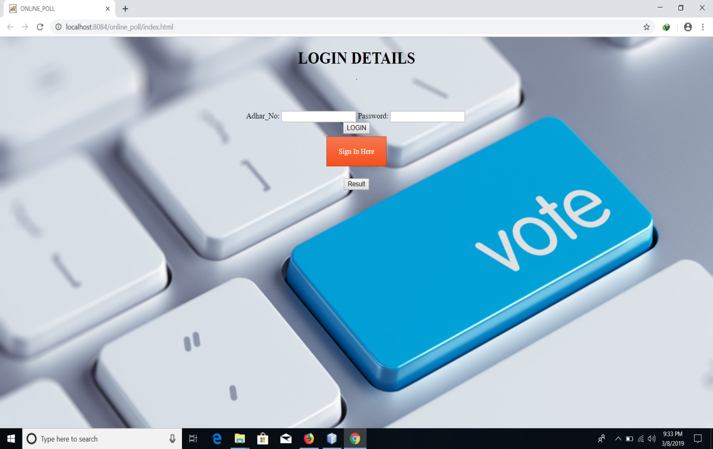

**Sign up Blank Page :**

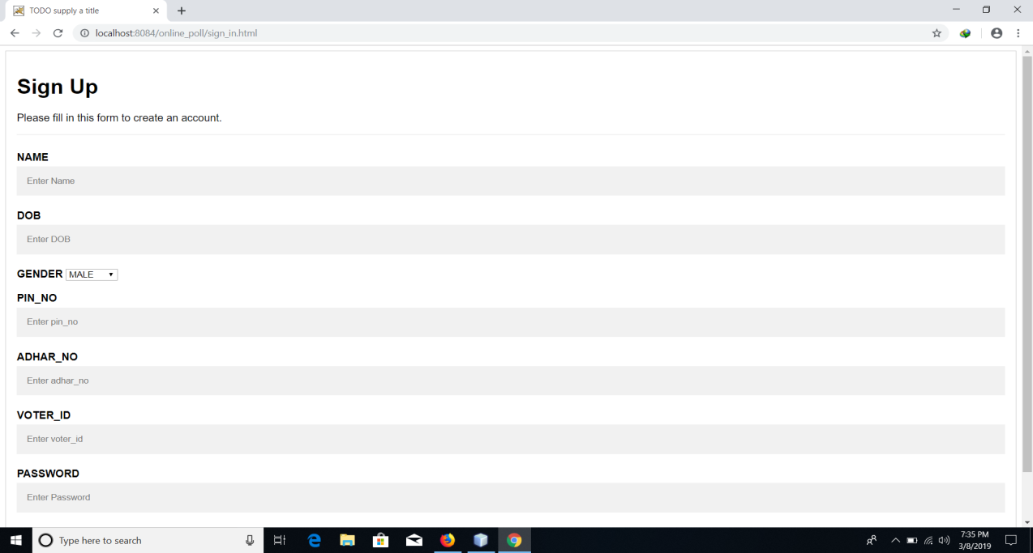

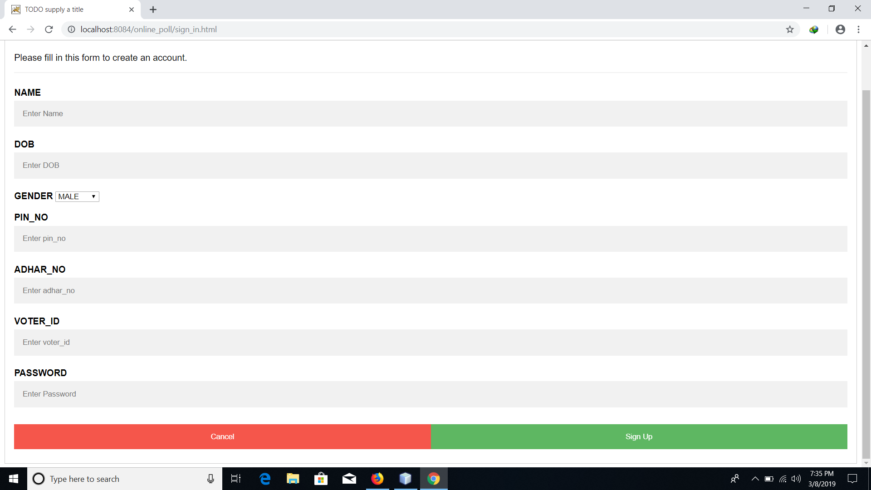

**Filled-up sign in page**

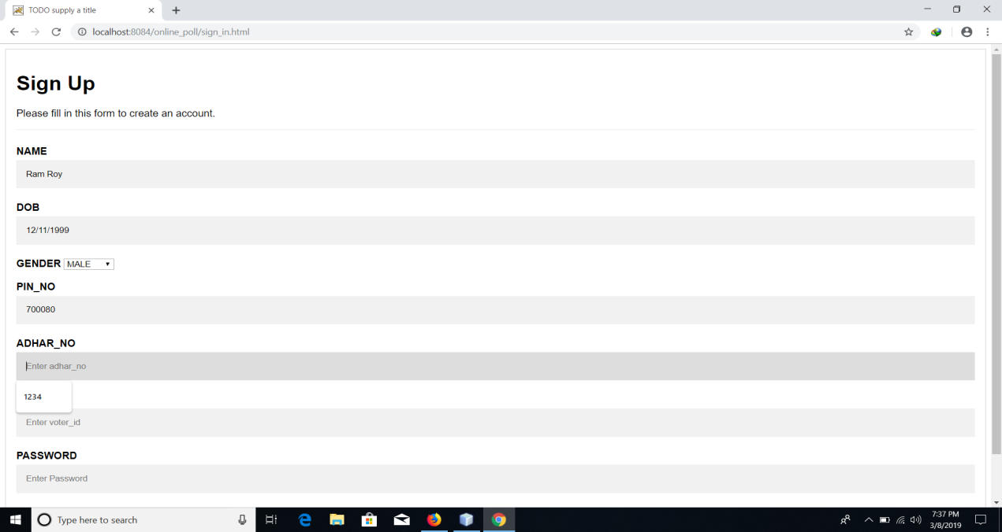

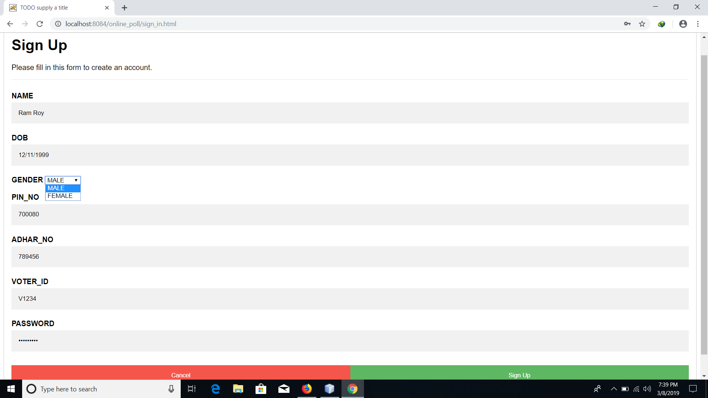

**Successful sign-up**

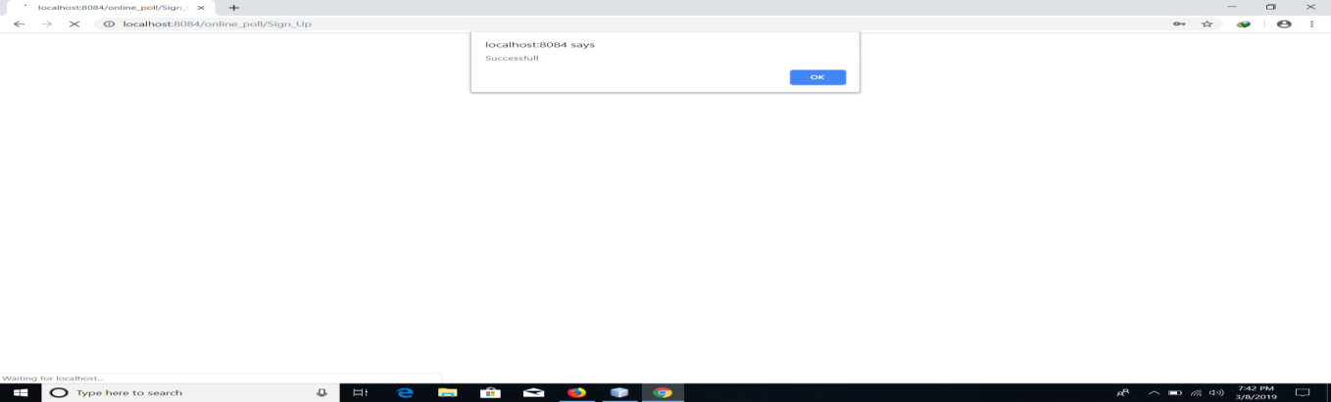

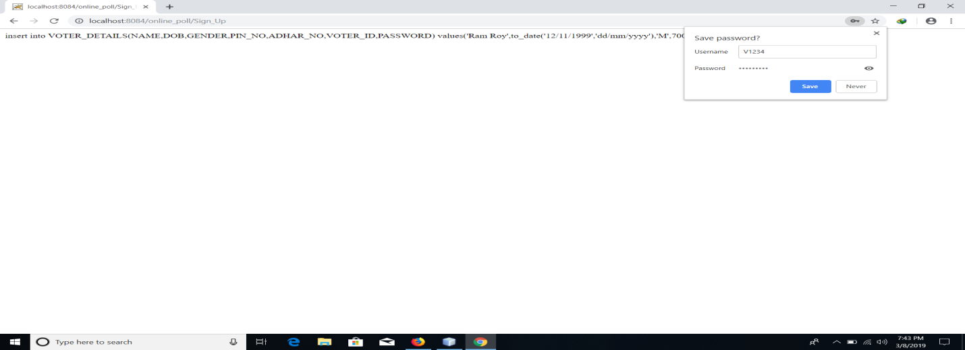

**Logging in**

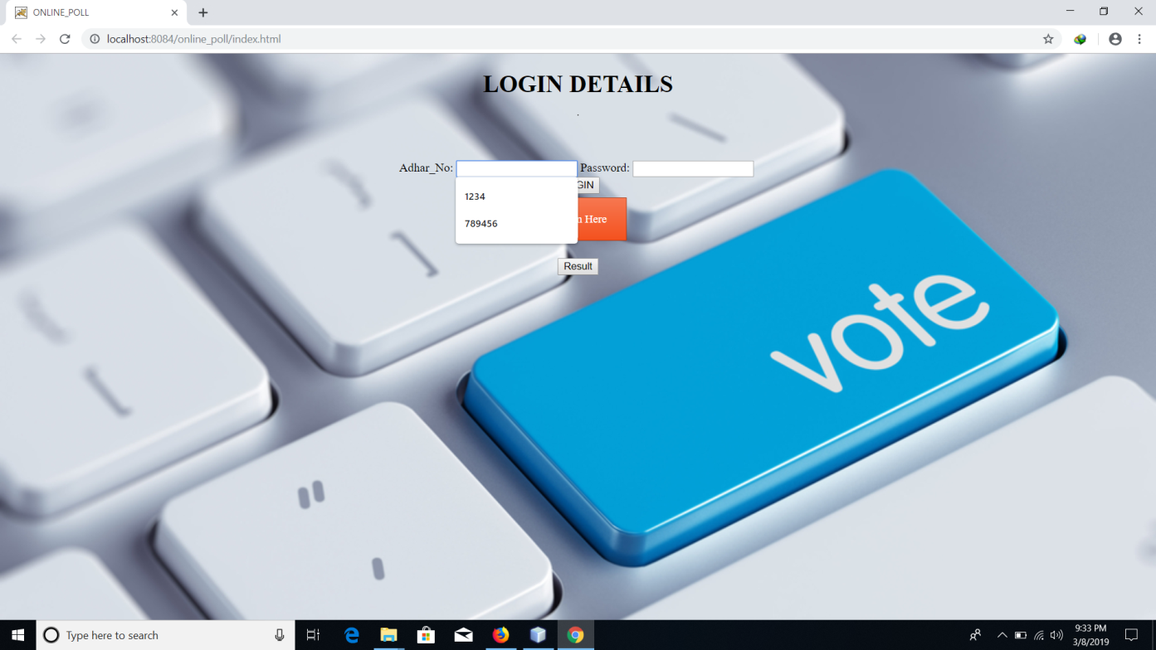

**Casting page**

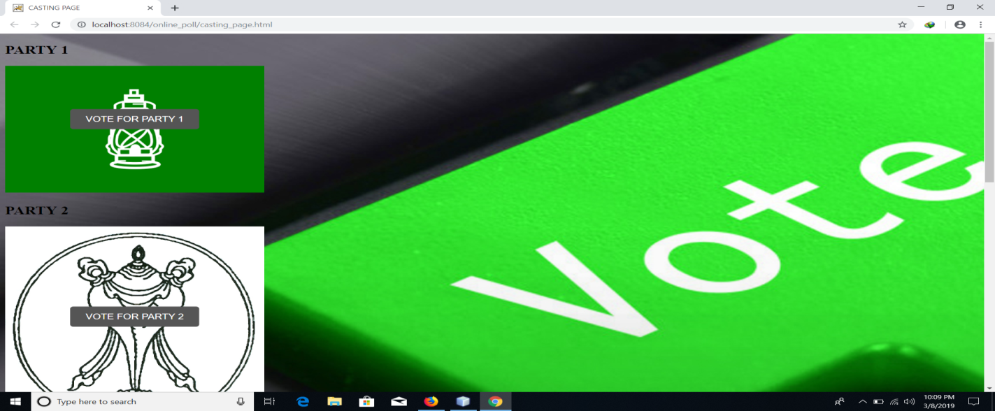



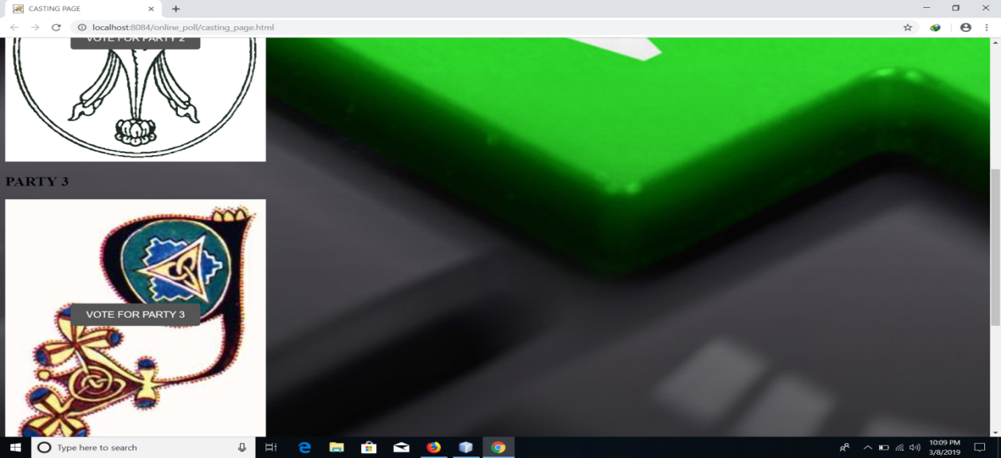

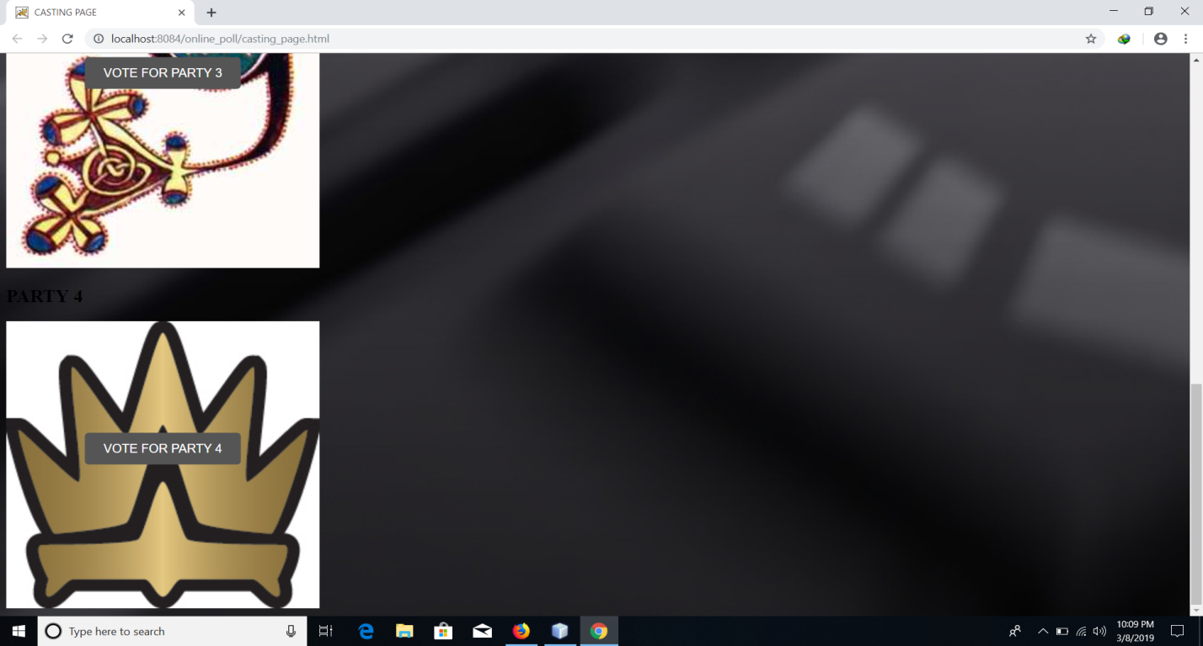

**Displaying result**



**Conclusions**

This Online Polling System will manage the voter’s information by which voter can login and use his/her voting rights. The system will incorporate all features of voting system. It provides the tools for maintaining voter’s vote to every party and it count total number of votes of every party. There is a DATAABASE which is maintained by the Election Commission of India in which al the names of voter with complete information is stored.

In this user who is above 18 years, register his/her information on the database and when he/she want to vote , he/she has to login by his/her id and password and ca vote to any party only single time. Voting details storeed in database and he result is displayed by calculation. By online voting system percentage of voting is increased. It decreases the cost and time of voting process. It is very easy to use and it is less time consuming. It is very easy to debug.

**Bibliography :**

1. [WWW.BMC.COM](http://WWW.BMC.COM)
2. WWW.ORACLE.COM
3. [WWW.W3SCHOLS.COM](http://WWW.W3SCHOLS.COM)
4. WWW.STACKOVERFLOW.COM